Tree Growing
A small tree was planted in a meadow | After 20 years it has grown into a big tree, weighing 500 lb more than when it was planted.

Tree Decaying
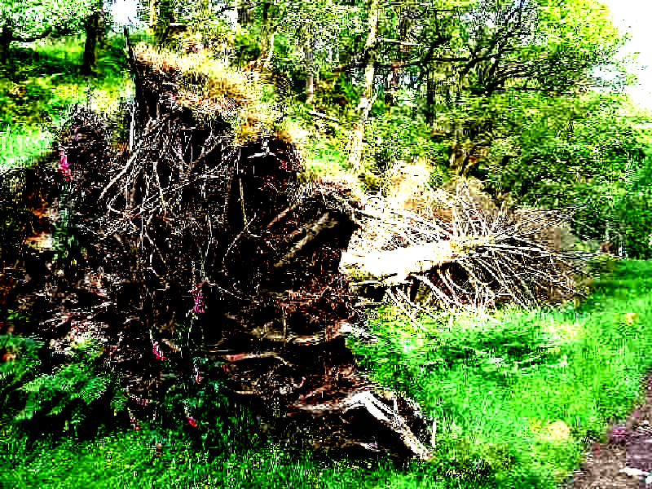
A tree falls in the forest. After many years, the tree will appear as a long, soft lump barely distinguishable from the surrounding forest floor.

Burning Match   | Burning Candle  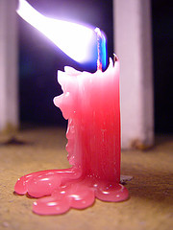

Car Running
Tom’s family went to Chicago on vacation. When they came back, Tom’s dad found that their car consumed 50 gallons of gasoline for the trip.

Lamp lighting


A Baby Girl Growing
 | 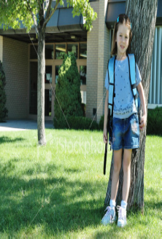
The baby weighed 22 lb when she was 5 months old. | The baby has grown into a big girl, weighing 50 lb.

A Girl Running


Atmosphere
Soil Containing decomposers, plants and animal remains
Coal
Natural Gas
Oil
Sea Creatures

